# Brainstorm

### Before you collaborate

A little bit of preparation goes a long way with this session. Here’s what you need to do to get going.

**10 minutes**

**1**

### Define your problem statement

What problem are you trying to solve? Frame your problem as a How Might We statement. This will be the focus of your brainstorm.

**5 minutes**

**2**

### Brainstorm

Write down any ideas that come to mind that address your problem statement.

**10 minutes**

**3**

### Group ideas

Take turns sharing your ideas while clustering similar or related notes as you go. Once all sticky notes have been grouped, give each cluster a sentence-like label. If a cluster is bigger than six sticky notes, try and see if you and break it up into smaller sub-groups.

**20 minutes**

**4**

### Prioritize

Your team should all be on the same page about what's important moving forward. Place your ideas on this grid to determine which ideas are important and which are feasible.

**20 minutes**

# & idea prioritization

Blood pressure

#### Use this template in your own brainstorming sessions so your team can unleash their imagination and start shaping concepts even if you're not sitting in the same room.

**10 minutes** to prepare

**1 hour** to collaborate

**2-8 people** recommended

1. **Team gathering**

Define who should participate in the session and send an invite. Share relevant information or pre-work ahead.

1. **Set the goal**

Think about the problem you'll be focusing on solving in the brainstorming session.

1. **Learn how to use the facilitation tools**

Use the Facilitation Superpowers to run a happy and productive session.

[**Open article**](https://support.mural.co/en/articles/2113740-facilitation-superpowers)

**PROBLEM**

The leading cause of death in the developed world is heart disease. Therefore, there needs to be work done to help prevent the risks of having a heart attack or stroke.

**Key rules of brainstorming**

To run an smooth and productive session

**BHUVANESHWARI G**

##### Implementing the code

Loading the dataset

##### Visualize the dataset

Understand the dataset

**SONA T**

Interactive

By making use of IBM cloud

Achieving a high accuracy

Keeping up with current trends

Collecting the proper datasets

Notification to respective caretaker

## 

Charts

Frequent Updates

Stay in topic. Defer judgment.

Encourage wild ideas. Listen to others.

**ASWINI P**

**MONISHA RT**

**Importance**

Heart

patients

Heart rate

If each of these tasks could get

Regular Checkup

access

Easy

**Data Visibility**

**Graphs**

|  |  |
| --- | --- |
|  |  |
|  |  |

Go for volume. If possible, be visual.

yone

Making use of MachineLearning Techniques

utilising the exploration of data

Implementing Data Scine

Assembling details of blood pressure, cholesterol

done without any difficulty or cost, which would have the most positive impact?

By using data mining techniques

##### Knowing the project flow

Gathering details of ECG

Using Technical articles

phs

Gra

Slopes

Pulse

Elderly people

by an

[**Share template feedback**](https://muralco.typeform.com/to/CiqaHVat?typeform-source=app.mural.co)

**Feasibility**

Regardless of their importance, which tasks are more feasible than others? (Cost, time, effort, complexity, etc.)

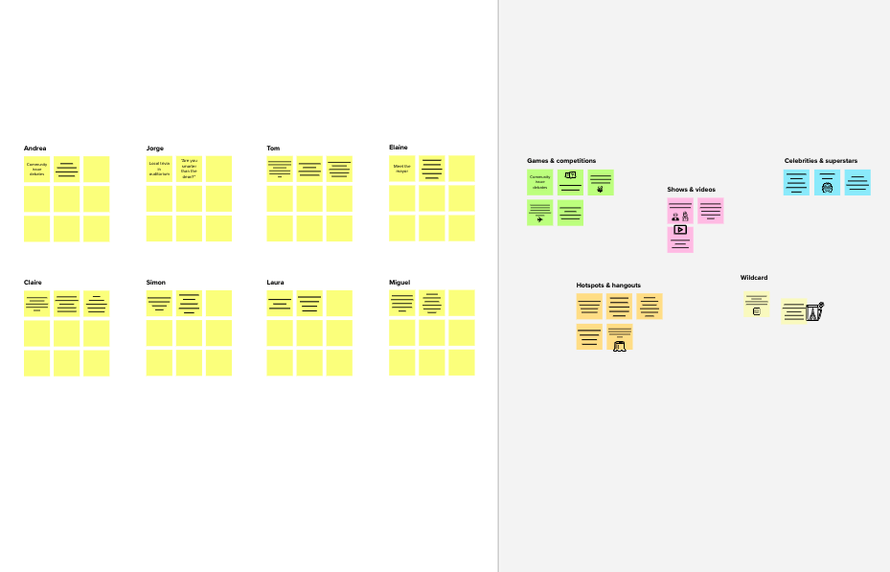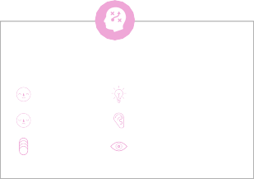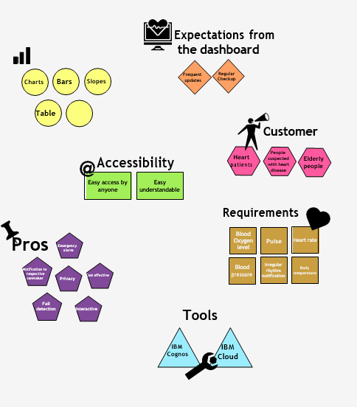

**After you collaborate**

You can export the mural as an image or pdf to share with members of your company who might find it helpful.

**Quick add-ons**

**A Share the mural**

**Share a view link** to the mural with stakeholders to keep them in the loop about the outcomes of the session.

**B Export the mural**

Export a copy of the mural as a PNG or PDF to attach to emails, include in slides, or save in your drive.

**Keep moving forward**

**Strategy blueprint**

Define the components of a new idea or strategy.

[**Open the template**](https://app.mural.co/template/e95f612a-f72a-4772-bc48-545aaa04e0c9/984865a6-0a96-4472-a48d-47639307b3ca)

**Customer experience journey map**

Understand customer needs, motivations, and obstacles for an experience.

[**Open the template**](https://app.mural.co/template/b7114010-3a67-4d63-a51d-6f2cedc9633f/c1b465ab-57af-4624-8faf-ebb312edc0eb)

**Strengths, weaknesses, opportunities & threats**

Identify strengths, weaknesses, opportunities, and threats (SWOT) to develop a plan.

[**Open the template**](https://app.mural.co/template/6a062671-89ee-4b76-9409-2603d8b098be/ca270343-1d54-4952-9d8c-fbc303ffd0f2)

[**Share template feedback**](https://muralco.typeform.com/to/CiqaHVat?typeform-source=app.mural.co)

**Template**

**Need some inspiration?**

See a finished version of this template to kickstart your work.

[**Open example**](https://app.mural.co/template/e5a93b7b-49f2-48c9-afd7-a635d860eba6/93f1b98d-b2d2-4695-8e85-7e9c0d2fd9b9)